**One:**

However, we are still **waiting for a couple of key components such as Letters of Credits for us to go back at least one more year of analysis**. The Master tab includes NCO, Provisions, ACL Change (single factor) analysis you requested the other day.

**Some observations from the charts:**

**SBNA:**

* **The wide gap between Cost if Credit and NCO is because during the time of 2014 until mid-2015, there were no Provisions made by the bank. Once the bank started provisioning for losses the Provisions and Net charge offs converged.**
* **Provisioning is based on management decision. No provisioning in previous years lowers mean value and thus trigger & limit value.**
* **The Group methodology may not apply to an unsteady entity like SBNA (confirmed with Bea).**

**SC:**

* **The wide gap at the beginning of 2015 is due to large Provisions compared with the Charge Offs. However, NCO converges with Provisions starting from Sept. 2015 due to a large increase in NCO with Provision remaining the same.**
* **SC NCO monthly increase (Sept 2015) was due to the personal lending portfolio which is classified as Available For Sale(AFS)—Confirmed with Ramez. We are checking GAAP accounting principles for treatment of AFS asset to understand more.**

PR:

* **Puerto Rico has a very similar trend for Cost of Credit and NCO.**
* **Provision started to pick up in Q4 2015 probably due to macro-economic concern** (On August 3, 2015, Puerto Rico defaulted on a $58 million bond payment to the Public Financing Corporation, a subsidiary of the Government Development Bank). (pending confirmation with PR tomorrow)—Confirmed with Ramos da Silva, Joao Pedro M (Credit Officer) Being specific, PR has businesses (e.g. loan a government sponsored entity to build a hotel) with PR government. PR is provisioning more due to the concern of potential government default.

NY:

* **NY customers are large customers classified under the Global Corporate Banking business line, these customers are more likely to use Letters of Credit.**

**Two:**

Allowance for Credit Loss 12 Months Rolling Change in the Excel is calculated based on NCO and Provision. **The only relatively significant difference is due to management decision occurred in Aug. 14. ACL depleted by ~70MM (circled in orange below)**

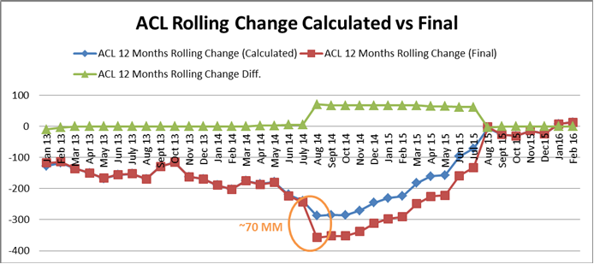

**Three:**

NPL: overdue time is at least 90 days/61+: overdue time is between 61 and 89 days

**Some Observations:**

**For SBNA**

* 61+ is relatively stable. NPL is also **stable** except for the decrease in Aug 14, the same month we see ACL depletion based on management decision. That might suggest the bank sold/collected existing non-performing loans during that period. Therefore, the bank has lower requirements for reserves. We have scheduled some time with Brian Lynch tomorrow to confirm our assumption.

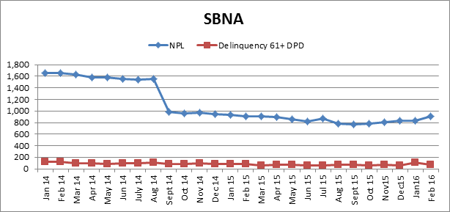

**For SC**

* Both NPL and 61+ trends up, especially for NPL. That might suggest subprime loans which SC carries heavily become more likely to default. This trend aligns that SC is provisioning more in our prior analysis.

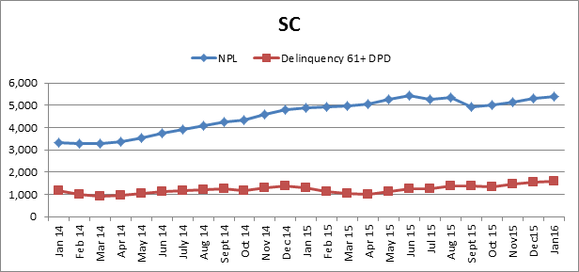

**Other Updates:**

* Ramez said they track ACL post management adjustment and don’t document the prior.
* 61+ delinquency rates are typically expressed as a percentage of a group of loans written within a specified time period. This figure is used when analyzing loan portfolio performance, which produces a metric of a lender's performance. We can follow up to make this analysis if needed.
* **On NPL coverage** what will come in handy is **a back history of NPL months coverage**. But again, no immediate rush while we discuss how we adapt these metrics to US application.